Practical - 7
Practical Title: PHP Form Processing with Server-Side Validation and CSV/JSON File Storage

Process submitted registration/contact form data using PHP. Validate and sanitize inputs on the server side and store records in CSV or JSON file format. Display success/error messages.

1. Is the form submitted using POST?
- Yes, the form is submitted using the POST method.
- POST is used to send form data securely to the PHP backend.
- The submitted data is not displayed in the URL.

2. Are inputs validated and sanitized server side?
- Yes, inputs are validated on the server side using PHP.
- Required fields are checked before processing.
- Email format and other input formats are validated.
- Input data is sanitized to remove unwanted or harmful characters.
- Prepared statements are used when inserting data into MySQL to prevent SQL injection.
- Invalid or duplicate inputs are rejected with an appropriate error message.

3. Is file writing handled safely?
- Yes, file writing is handled safely.
- Data is read from external JSON files using the Fetch API.
- The application does not directly overwrite or modify the original JSON files.
- User input is only used for search, filtering, sorting, and pagination.
- Proper error handling is used if the JSON file cannot be loaded.

4. Are success and error responses displayed clearly?
- Yes, success and error responses are displayed clearly.
- Success messages confirm that the operation was completed successfully.
- Error messages clearly indicate what went wrong.
- Messages are displayed directly on the webpage for easy understanding.
- The responses help users identify whether their action was successful or needs correction.

Implementation/ Output/Result
Implemented a PHP form processing system to handle registration/contact form submissions. Added server-side validation and input sanitization to ensure valid and secure data. Stored submitted records in CSV or JSON files and displayed appropriate success or error messages.

Evidence of Work (Screenshots)
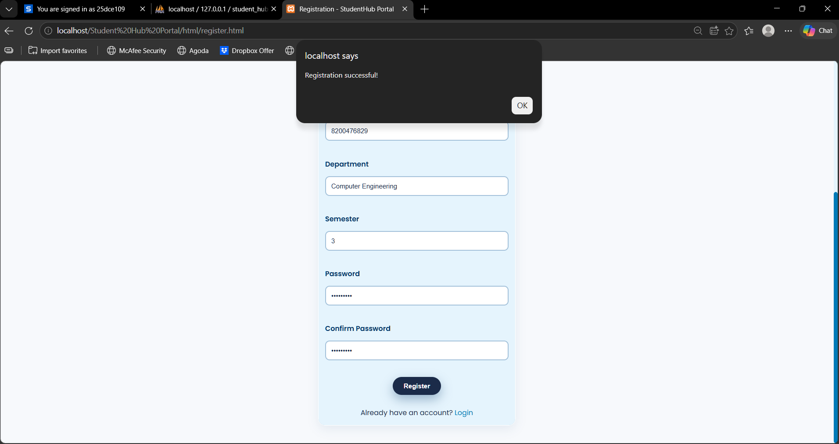
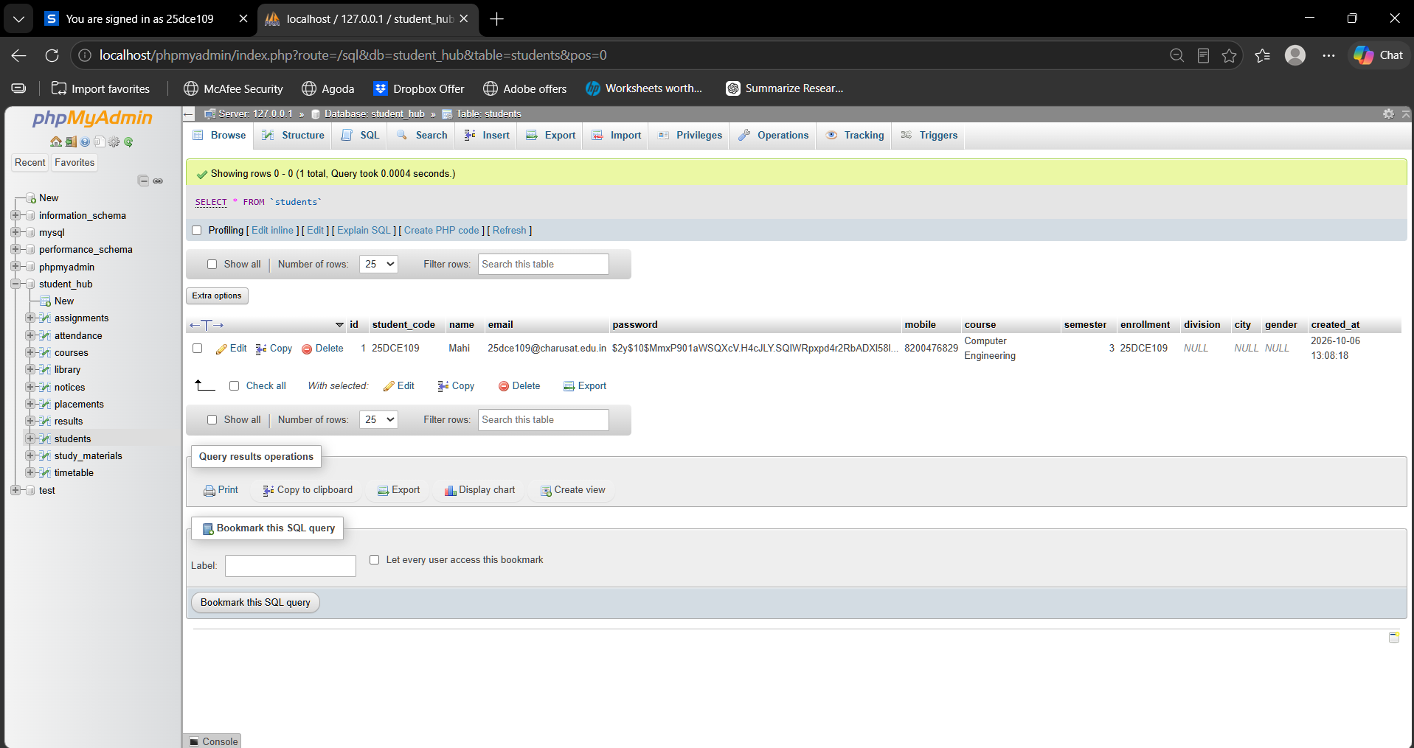

GitHub Repository Link: https://github.com/shahmahi0717/Student-Hub-Portal

Challenges Faced:
• Validating and sanitizing user inputs using PHP.
• Storing form data correctly in CSV or JSON format.
• Displaying appropriate messages for successful and unsuccessful submissions.

Learning Outcomes:
• Learned to process HTML form data using PHP.
• Understood server-side validation and input sanitization.
• Gained practical knowledge of CSV and JSON file handling.
• Learned to display success and error messages based on form submission results.

Faculty Remarks:

